

**Company**

**LOGO**



# XU XIANG QQ：5322961

**Email**： **[xuxiang@uestc.edu.cn](mailto:xuxiang@uestc.edu.cn)**



Multimedia-Experiment-2



**Audio Functions**

## % Read the audio [y,Fs] = audioread();

% Play the audio sound(y,Fs);

% Save Audio audiowrite('Nokia_edit.wav',y,Fs);

% Read only the first 2 seconds. samples = [1,2*Fs];

clear y Fs

[y,Fs] = audioread(filename,samples);



**Audio Functions**

% Record Voice and Play

fprintf('Press any key to start %g seconds of recording... \n',5);

pause; fprintf('Recording...\n');

recorder = audiorecorder(44100,16,1); record(recorder, 5)

pause(1) fprintf('5\n'); pause(1) fprintf('4\n'); pause(1) fprintf('3\n'); pause(1) fprintf('2\n'); pause(1) fprintf('1\n'); pause(1)

fprintf('Finished recording.\n');

fprintf('Press any key to play the recording...\n'); pause;

play(recorder)



**Experiment 2**

1. You have two audio files: “I Will Always Love You.mp3” and “Nokia.wav”.
2. Use MATLAB to read both files and play. Plot the audio waves.

>> % Read the audio

>> [y,fs] = audioread('Nokia.wav');

>> %play the audio

>> sound(y,fs);

>> [y,Fs] = audioread('Nokia.wav');

>> t1 = linspace(0,length(y)/Fs,length(y));

>> plot(t1,y);

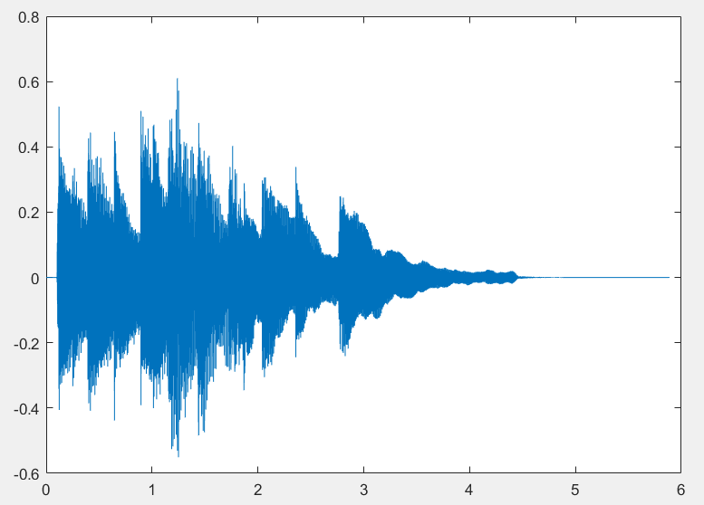

>> [y,Fs] = audioread('I Will Always Love You.mp3');

>> sound(y,Fs);

>> t = linspace(0,length(y)/Fs,length(y));

>> plot(t,y);

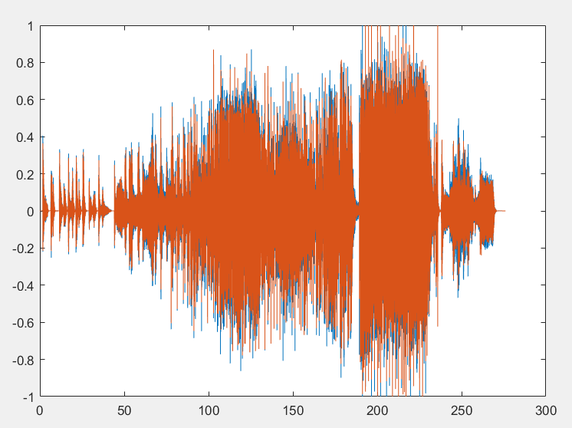

1. Use MATLAB to record your voice(10seconds) and play, and save it as “MyVoice.wav” file. Plot the audio waves.

% Record Voice and Play

fileName = 'Myvoice.wav';

fprintf('Press any key to start %g seconds of recording... \n',10);

pause;

fprintf('Recording...\n');

rcd = audiorecorder(44100,16,1);

count = 10;

Fs = 44100;

for i= 1:10

record(rcd, 10)

pause(1)

fprintf('%d\n', count);

count = count-1;

end

fprintf('Finished recording.\n');

fprintf('Press any key to play the recording...\n');

pause;

play(rcd);

y = getaudiodata(rcd);

plot(y);

audiowrite(fileName,y,round(Fs));

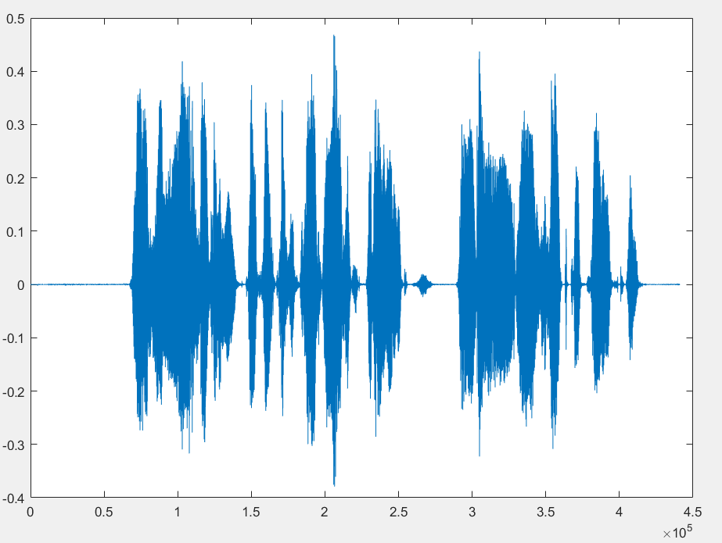

1. Change the sampling rate of the above three files to ½, ¼, 1/8 and 1/16, and play to compare with the original audios, and describe the difference.

% sampling rate

[y,Fs]= audioread('Nokia.wav');

[x,Fx] = audioread('I Will Always Love You.mp3');

[w,Fw] = audioread('Myvoice.wav');

A = audioplayer(y,Fs);

B = audioplayer(x,Fx);

C = audioplayer(w,Fw);

%playing the audio

playblocking(A);

playblocking(B);

playblocking(C);

A.SampleRate = 0.5*Fs; % sampled by 1/2

B.SampleRate = 0.5*Fx;

C.SampleRate = 0.5*Fw;

playblocking(A);

playblocking(B);

playblocking(C);

A.SampleRate = 0.25*Fs; %sampled by 1/4

B.SampleRate = 0.25*Fx;

C.SampleRate = 0.25*Fw;

playblocking(A);

playblocking(B);

playblocking(C);

A.SampleRate = 0.125*Fs; % sampled by 1/8

B.SampleRate = 0.125*Fx;

C.SampleRate = 0.125*Fw;

playblocking(A);

playblocking(B);

playblocking(C);

A.SampleRate = 0.0625*Fs; % sampled by 1/16

B.SampleRate = 0.0625*Fx;

C.SampleRate = 0.0625*Fw;

playblocking(A);

playblocking(B);

playblocking(C);

1. Change the bit depth of the three original audios from 16 bits to 8 and 4, and play to compare, describe the difference.

%changing the bitdepth

[y,Fs] = audioread('Nokia.wav');

sound(y,Fs);

sound(y,Fs,16);

sound(y,Fs,8);

%sound(y,Fs,4); %not supported, Currently only 8, 16, and 24-bit audio is supported.

[z,Fz] = audioread('I Will Always Love You.mp3');

sound(z,Fz);

sound(z,Fz,16);

sound(z,Fz,8);

%sound(z,Fz,4); %not supported , Currently only 8, 16, and 24-bit audio is supported.

[w,Fw] = audioread('Myvoice.wav');

sound(w,Fw);

sound(w,Fw,16);

sound(w,Fw,8);

%sound(w,Fw,4); %not supported, Currently only 8, 16, and 24-bit audio is supported.

1. Change the amplitude of the three original audios to ½, ¼, double and four times as original amplitude, then play to compare and describe the difference.

%changing the amplitude

[y,Fs] = audioread('Nokia.wav');

[z,Fz] = audioread('I Will Always Love You.mp3');

[w,Fw] = audioread('Myvoice.wav');

p = audioplayer(0.5*y,Fs);

q = audioplayer(0.5*z,Fz);

r = audioplayer(0.5*w,Fw);

playblocking(p);

playblocking(q);

playblocking(r);

p = audioplayer(0.25*y,Fs);

q = audioplayer(0.25*z,Fz);

r = audioplayer(0.25*w,Fw);

playblocking(p);

playblocking(q);

playblocking(r);

p = audioplayer(2*y,Fs);

q = audioplayer(2*z,Fz);

r = audioplayer(2*w,Fw);

playblocking(p);

playblocking(q);

playblocking(r);

p = audioplayer(4*y,Fs);

q = audioplayer(4*z,Fz);

r = audioplayer(4*w,Fw);

playblocking(p);

playblocking(q);

playblocking(r);

1. Write a conclusion of the influence of audio elements, including: audio frequency, pitch, amplitude, sound intensity, sampling rate, bit depth and etc.

The influences of audio Elements in the Quality of the Audio

1. Audio Frequency:

Audio frequency has directly proportional to the Quality of the audio the more the frequency means that the better the Quality of the audio will be.

Pitch: The Higher the pitch the , the better the sound of an audio file.

Sampling rate : reducing the sampling rate will reduce the size of the file at the some time the Quality of the audio will reduce.

Even though increasing the sampling rate will increase the size of the file.

In order to listen a Quality audio we must increase the sampling rate.

Bit depth: has directly directly proportional to the quality of the audio as well as the amount of file size.

Increasing the bit depth means increasing the file size, the more the size of the file the better the audio to listen.

In general in order to listen a Quality audio , it’s advisable to increase the sampling rate , the bit depth , sound frequency , and pitch of the audio file.

1. In each step, you should put all the codes, figures and description text in

your reports step by step.